 | Monday  December 2023 | Tuesday | 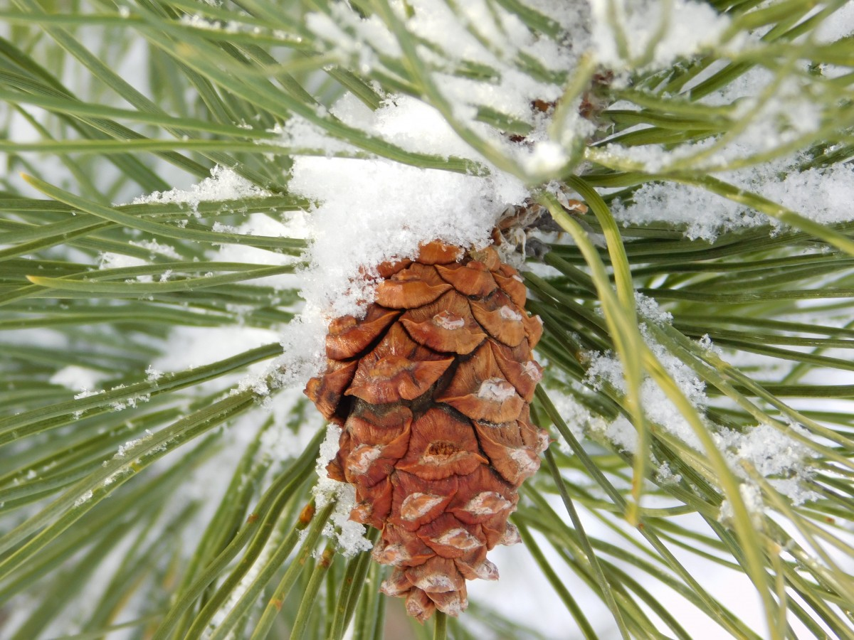  Wednesday | Thursday | Friday | Saturday
 |  |  |  |  | 1  9:00 Crafts w/Deb 10:00 Cardio Drumming 3:00 Tea Time Readers 2:00 Brenda & Nadine String Duet | 2  10:00 Dollar Bingo 1:00 Wii Bowling 2:00 Susan’s Exercise 3:00 Euchre!
3 | 4 8-10am RISE & SHINE Breakfast | 5 | 6 | 7 | 8 | 9
10:30AM Sunday Service 2:00 Susan’s Exercise 3:00 Euchre! | 10:30 Reminisce 3:00 Euchre & Dominoes | 10:00 BINGO! 1:00 Wii Bowling  1:30 Shopping & Errands  6:30 Pitch Piper’s Christmas | 10:30 Sam & Serena  2:00 Exercise W/Britt  3:00 Popcorn Theater “How the Grinch Stole Christmas” | 9:00 Christmas Gift Wrapping 11:00 Bible Devotions  3:00 Exercise w/Mary | 10:00 Cardio Drumming 1:00 YMCA BINGO!  2:00 Exercise w/Britt  3:00 Tea Time Readers | 1:00 Wii Bowling  2:00 Brittany’s Exercise
10 | 11 | 12 Happy Birthday JO! | 13 | 14 | 15 | 16
10:30AM Sunday Service 2:00 Britt’s Exercise | 10:30 Catholic Mass 10:30 Reminisce  1:00 Ukelele Strummers  6:00 Sweet Adeline’s Concert | 10:00 BINGO! 1:00 Wii Bowling  1:30 Shopping & Errands | 10:30 Sam & Serena  2:00 Exercise w/Britt 3:00 Popcorn Theater “A Christmas Carol” | 9:00 Pampered Hands 11:00 Bible Devotions 2:00 Music of Allan Shaffer  3:30 Auxiliary Games | 9:00 Christmas Wrapping 10:00 Cardio Drumming 2:00 Exercise w/Britt  3:00 Tea Time Readers 5:45 Christmas Lights Trip | 10:00 Dollar Bingo! 1:00 Wii Bowling  2:00 Susan’s Exercise  3:00 Euchre!
17 | 18 | 19 | 20 Happy Birthday MORI! | 21 | 22 | 23
10:30AM Sunday Service  2:00 Susan’s Exercise 3:00 Euchre! | 10:30 Reminisce  2:00 Andrea’s Exercise  3:00 Euchre & Dominoes | 10:00 BINGO! 1:30 Fremont School Christmas Concert  1:30 Shopping & Errands | 10:30 Sam & Serena Noon Resident Christmas Lunch!  2:00 Music w/Kevin Santus | 11:00 Bible Devotions 2:00 Music of Sam Hicks  3:00 Exercise w/Mary | 10:00 Cardio Drumming 2:00 Exercise w/Britt 3:00 Tea Time Readers 5:30 Christmas Lights Trip | 1:00 Wii Bowling  2:00 Brittany’s Exercise
24 | 25  This Photo by Unknown Author is licensed under CC BY-NC | 26 | 27 | 28 | 29 | 30
10:30AM Sunday Service 2:00 Britt’s Exercise 31 10:30 Sunday Service 2:00 Susan’s Exercise  This Photo by Unknown Author is licensed under CC BY-NC |  | 10:00 BINGO 1:00 Wii Bowling  1:30 Shopping & Errands | 10:30 Sam & Serena 2:00 Exercise w/Britt 3:00 Popcorn Theater “It’s a Wonderful Life” | 9:00 Pampered Hands 11:00 Bible Devotions 2:00 Amy Simons Music! | 2:00 Exercise w/Britt 3:00 Tea Time Readers | MPR Private Family Party

December Activities

1st Brenda Maurer & Nadine Prince Strings Duet
4th RISE AND SHINE Hot Breakfast 8-10am in the dining room
5th Pitch Piper’s Christmas
10th YMCA BINGO!
11th Sweet Adeline’s Christmas
11th Ukulele Strummers Christmas Sing Along
14th Auxiliary Games!
14th Allan Schaffer Music
15th & 22nd Holiday Lights Sleigh Ride (well, it’s in the bus but use your imagination.) Sign up to take a ride to see local holiday light displays!
14th & 28th PAMPERED HANDS
7th & 15th GIFT WRAPPING – bring any gifts you may need help wrapping and we can give you a hand! Paper, tape & bows on us!
19th Resident Christmas Lunch
20th Kevin Santus Music
21st Sam Hicks Music
25th Christmas Day – no activities scheduled
29th Music of Amy Simons – local talent who plays the flute and piano

** We must have a minimum of 8 residents for bus trips to happen. We can take up to 12 without walkers**
We are limiting our shopping/errands to Tuesday afternoons. We are able to pick up prescriptions, emergency grocery items and doctor’s visits Monday – Thursday 7am-4pm. PLEASE give us at least 24-hour notice of where you need to go and when so we can plan our day – THANK YOU!

